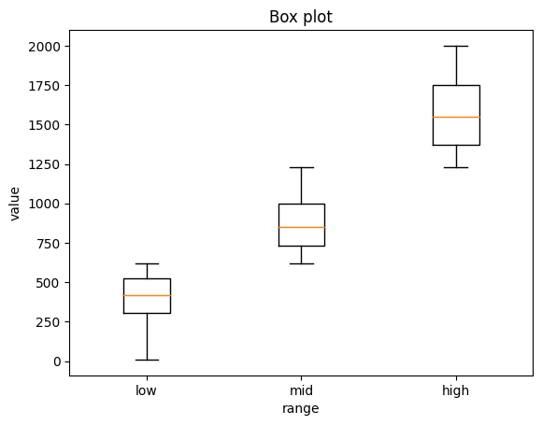 1)

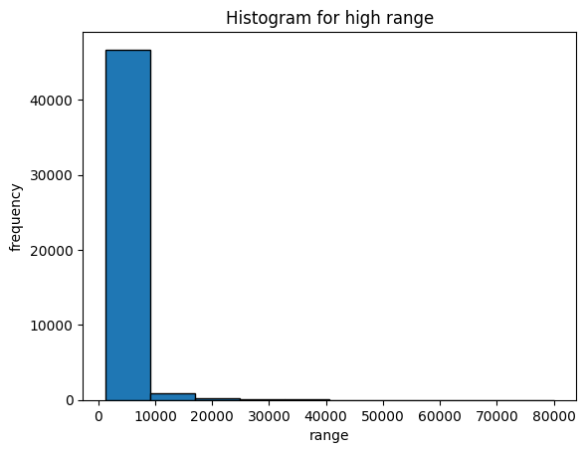

**Explanation:** Since every investor has different budget ranges and the goal is to divide the overall opportunities to all, I have taken the **price** column (sorted in in ascending order) and divided in to three ranges (low, medium, high).

Plotted a boxplot to show the mean, maximum and minimum value of three ranges.

Some of the values (outliers) in high range are ignored, since it has very low distributions for that particular value which is not useful for the plot. This is confirmed by plotting histogram.

That is more than 2000, we have less distribution in histogram

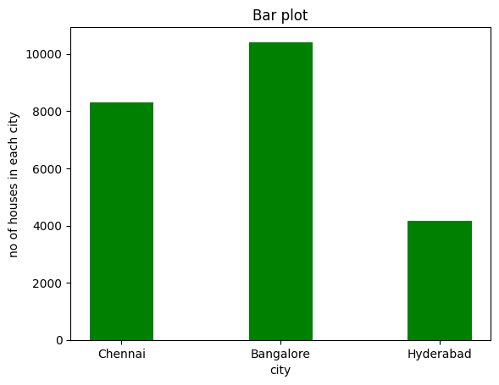

2)

**Explanation:** Some investors are interested only in tech-emerging cities like Hyderabad, Bangalore, and Chennai.

So, I took the no of houses available in each city and filtered by which has **is_ready_to_move** column as true and plotted the bar graph for the filtered values.

From the graph, we can infer that Bangalore has more no of ready to occupy properties compared to Chennai & Hyderabad.

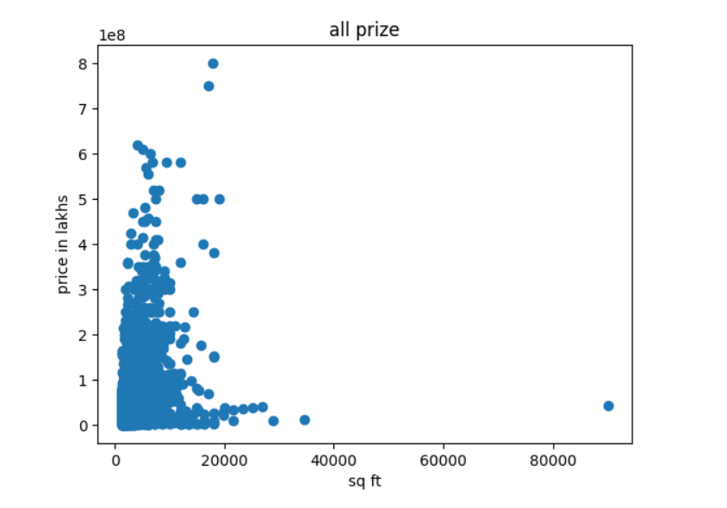3)

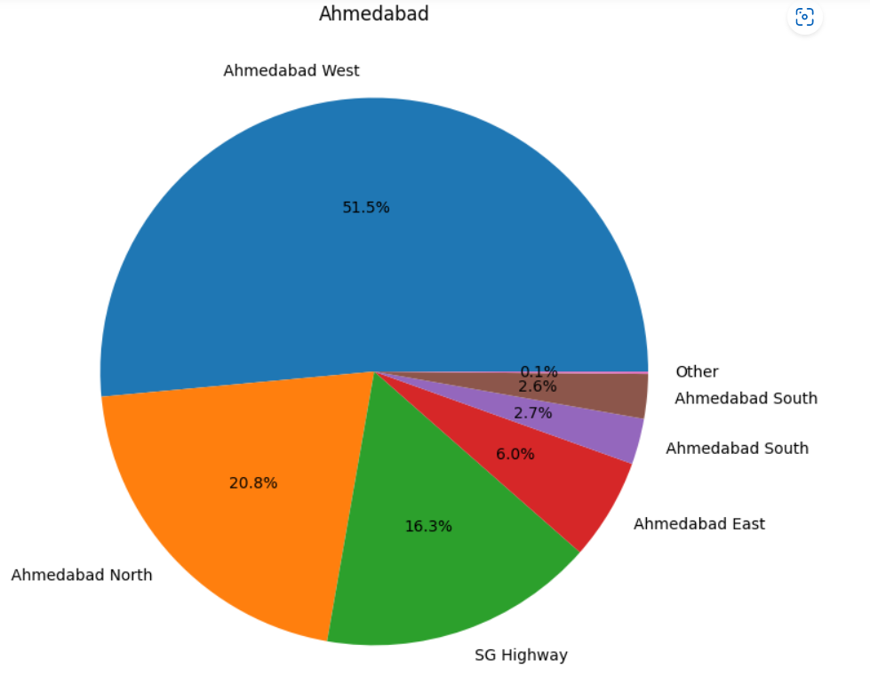

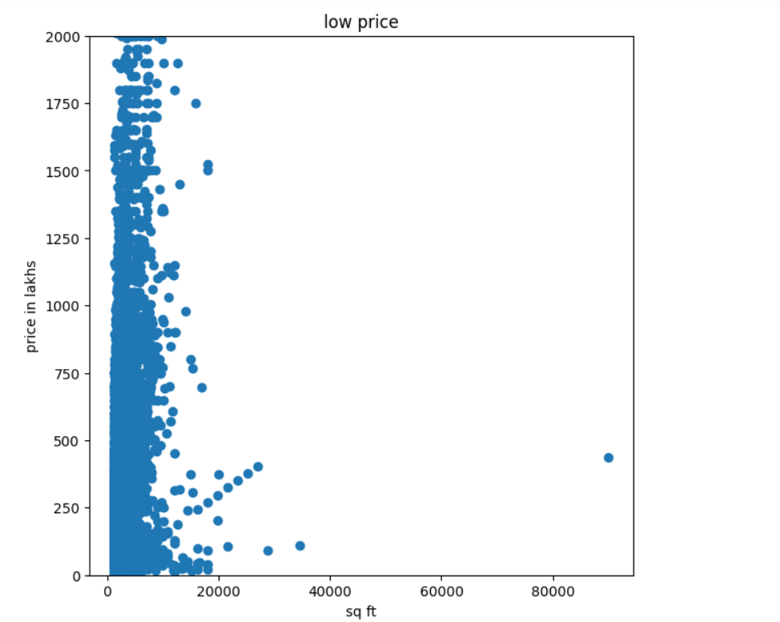

**Explanation:** Some prefer larger area properties with relatively lesser budgets.

So doing a scatter plot of area(sq ft) vs corresponding price will give us the information of large area properties with relatively less price values.

Since we are looking for large area properties, I dropped the properties data that has less than mean property value and limited the graph to lower price values (2nd graph) for better visualization.

From the graph, we can see some properties of size more than 20000 has relatively less price value compared to properties of size less than 20000.

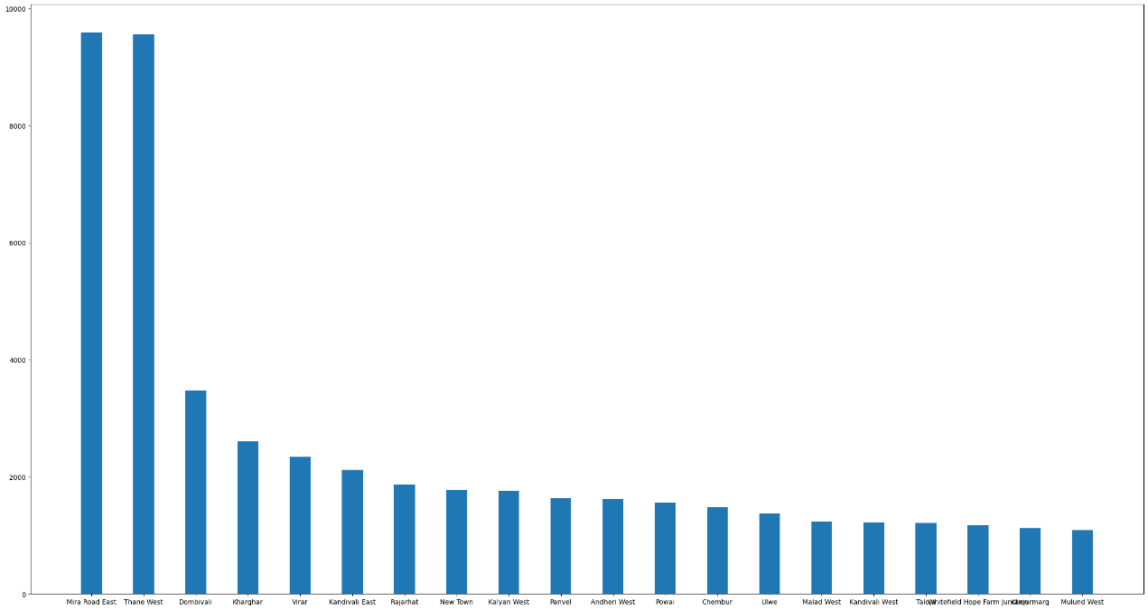4)

**Explanation**: Some investors prefer making all the investments in one locality.

So, I took the **Locality_Name** column and calculated the no of occurrence for each locality and plotted the bar graph for the same.

From the graph, it is observed that localities like **mira road west** & **thane west** would be more suitable for investors who prefer to investments in one locality. Since those two localities has more no of properties compared to other localities

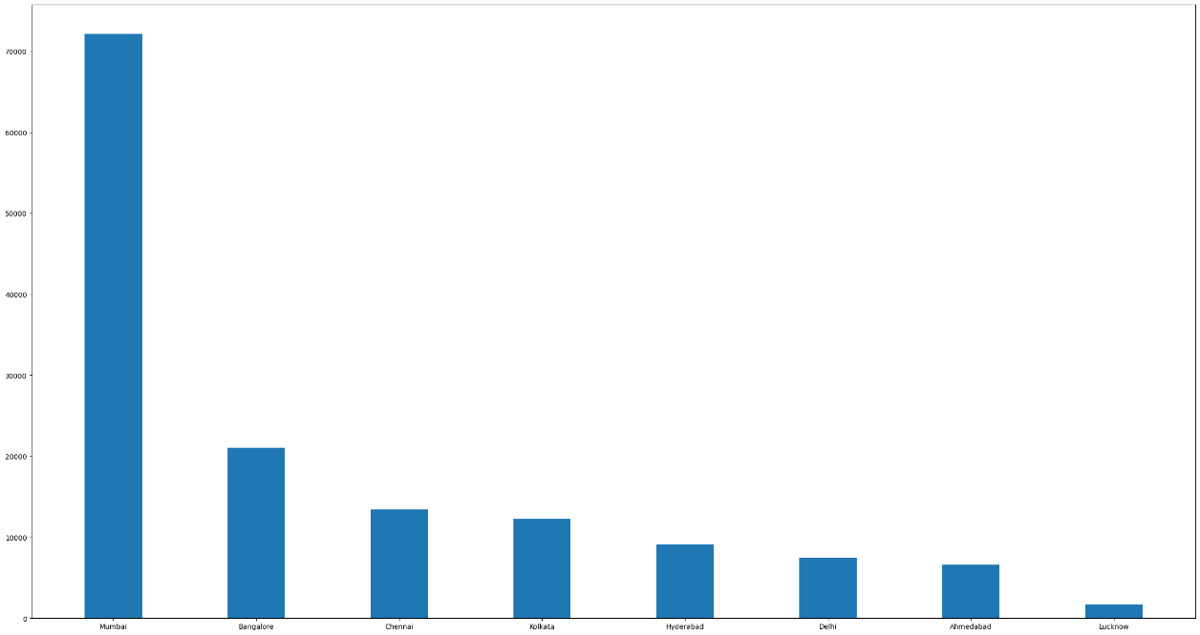

**Explanation**: People who are interested in diversifying the portfolio in one locality. Plotted the bar graph for the **city** column

From the graph, we can conclude that Mumbai would be suitable. Since it has more no of localities compare to the cities.

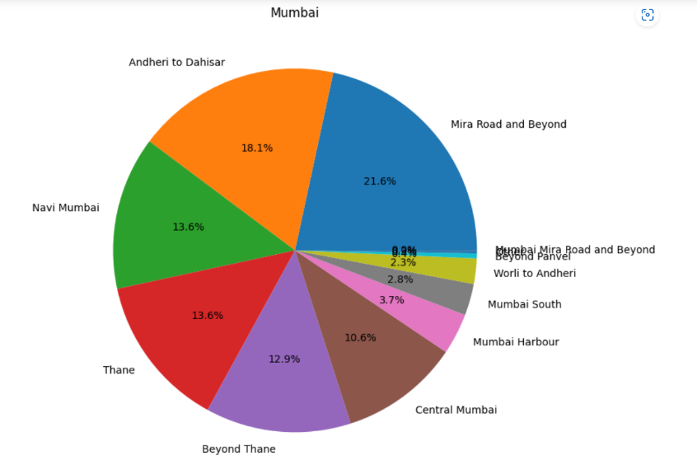5)

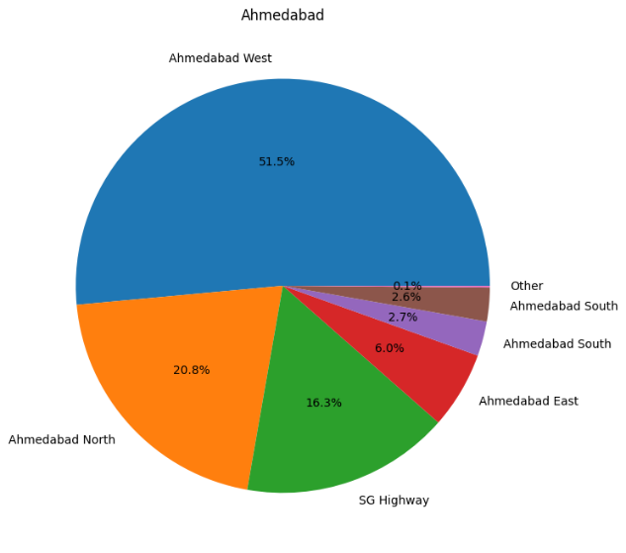

**Explanation**: Some investors are interested in knowing the hotspot for their offices in Mumbai and Ahmedabad.

So plotting pie chart for Mumbai & Ahmedabad would be better to know the hotspot in that particular city by calculating the no of occurrences for **Sub_urban_name**.

From the graph, Mira road in Mumbai & Ahmedabad West in Ahmedabad are hotspots.